Experiment 5: Data Visualization with Power BI.

Experiment 5: Introducing Power BI -Components and the flow of work. Power BI Desktop Interface- and identify the five main areas of a report.

Introduction to Power BI
Power BI is a powerful business analytics tool developed by Microsoft. It's designed to transform raw data into meaningful insights through interactive visualizations and comprehensive business intelligence capabilities. This versatile platform enables users across an organization to connect to various data sources, create dynamic reports and dashboards, and share valuable insights.

Objective of this Experiment:
- To introduce the key components of Power BI and explain the workflow of creating a report.
- To explore the Power BI Desktop Interface and identify the five main areas of a report.

Tools Required:
- Power BI Desktop installed on your machine.
https://www.microsoft.com/en-us/download/details.aspx?id=58494
The basic version of Power BI, called Power BI Desktop, is free to download and use. Power BI Desktop allows you to create reports, visualize data, and perform analysis for free.However, some features, such as sharing reports and collaborating through the cloud service (Power BI Service), may require a Power BI Pro subscription, which is paid.For local data visualization, the free version (Power BI Desktop) is typically sufficient.
- Sample data file (Excel or CSV) for demonstration.
- We will be using the supermarket store sales data as a launchpad for exploring the power of Power BI. This dataset provides a real-world glimpse into supermarket operations, offering valuable insights into customers, orders, purchased items, and payment methods. We will have the opportunity to explore customer segmentation, analyze sales performance, identify popular products, and understand customer payment preferences.
- This dataset will be used to practice data transformation and visualization techniques, enabling us to create insightful dashboards, draw meaningful conclusions, and gain valuable business intelligence from this comprehensive dataset.

Steps:

Step 1: Understanding the Components of Power BI
Power BI is composed of several components that work together to deliver a complete end-to-end BI solution:
- Power BI Desktop: The development tool used to create reports and visualizations. This is where you connect to data sources, clean and transform data, and design reports.
- Power BI Service (cloud-based): Used to share and publish reports online. Once reports are developed in Power BI Desktop, they can be uploaded to the Power BI service for sharing and collaboration.
- Power BI Mobile: Used to view reports and dashboards on mobile devices.
- Power BI Gateway: Acts as a bridge between on-premises data (such as SQL Server) and the Power BI service.

Step 2: Workflow in Power BI
- Connect to Data: Begin by importing data from various sources such as Excel, SQL databases, or web data sources.
- Transform Data: Use Power Query to clean and shape the data as required.
- Visualize Data: Design interactive reports and dashboards using visual elements like charts, graphs, tables, etc.
- Publish & Share: Publish the reports to the Power BI Service and share them with others.

Step 3: Exploring the Power BI Desktop Interface
Power BI Desktop is where users will spend most of their time. It contains several features and areas that are essential to developing and managing reports. The report interface is divided the following main areas:
- Ribbon:
- Located at the top of the window, it contains tabs like Home, Insert, Modelling, View, and Help.
- The ribbon provides quick access to commonly used commands for importing data, creating visuals, and formatting reports.
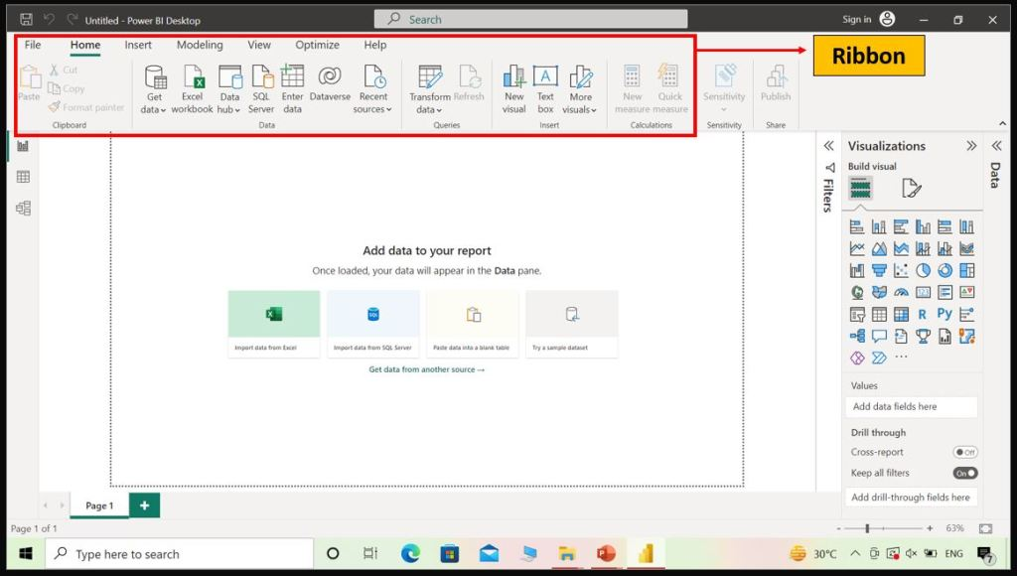

View Pane:
The View pane is located on the left side of the screen. There are three types of view. Report View, Data View, Model View.
- This is the central area where you create and modify reports by adding visual elements such as charts, maps, and graphs.It is the primary workspace for building interactive visualizations.
- Report view is the default view. Here, you can design and customize the visualizations based on your data. The report view consists of a canvas where you can drag and drop visual elements, such as charts, tables, and maps. You can also add filters, slicers, and other interactive components to enhance the user experience.
- Data View:
In Power BI, you can connect to various data sources, such as databases, Excel files, or cloud services. The data view allows you to manage and transform the data before creating visualizations. It provides options to perform data modeling tasks like creating relationships between tables, defining measures, and adding calculated columns. 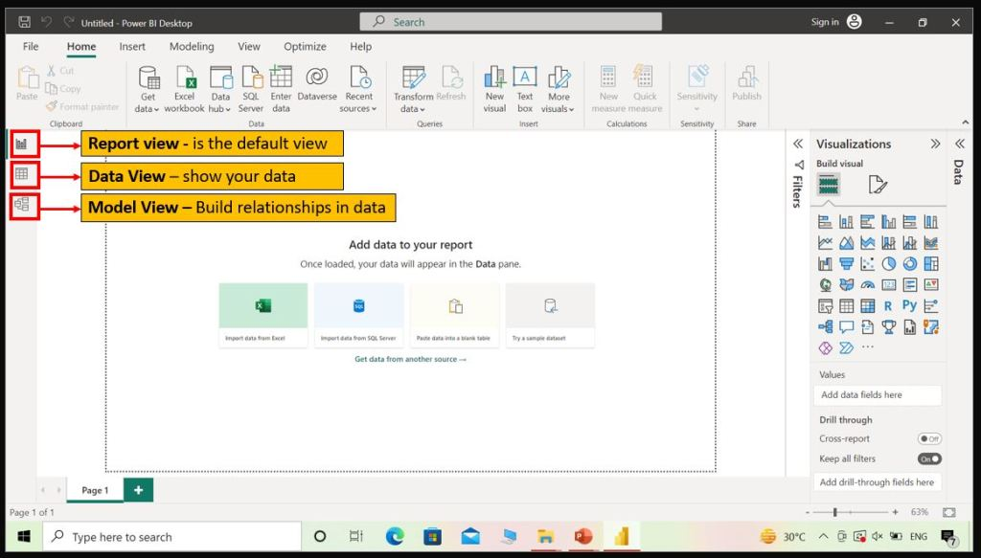
- Model View:
In Model View you can build relationships in data. I.e. relationships between different data sources. There are different types of relationships.

- Dashboard Canvas / Workspace:
- The canvas is the central area of the Power BI Desktop interface where you design and arrange visual elements, such as charts, tables, and images, to create your report. You can drag and drop visualizations onto the canvas, resize and rearrange them to create your desired layout.

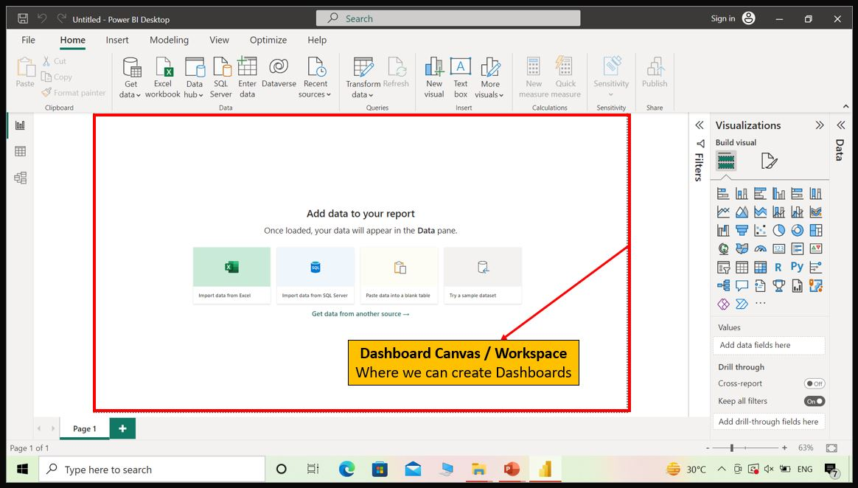

- Fields Pane:
- Located on the right side, this pane displays all the datasets and fields (columns and measures) available for report creation.
- You can drag fields into the canvas to create visualizations or into the filters to refine your report.

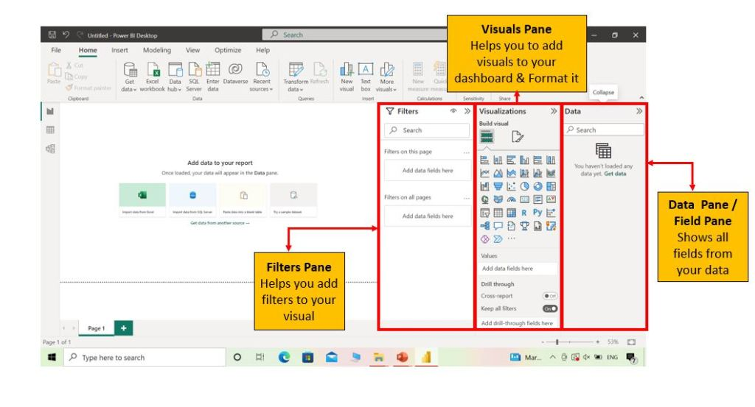
- Visualizations Pane:
- Also located on the right side, this pane shows different types of visualizations (e.g., bar charts, pie charts, tables, maps) that you can add to your report.
- You can change and customize visualizations from here.
- Pages:
- At the bottom of the report view, you will find pages, which allow you to create multiple pages in a single report.
- You can navigate between pages just like you would in Excel by clicking on the different page tabs.
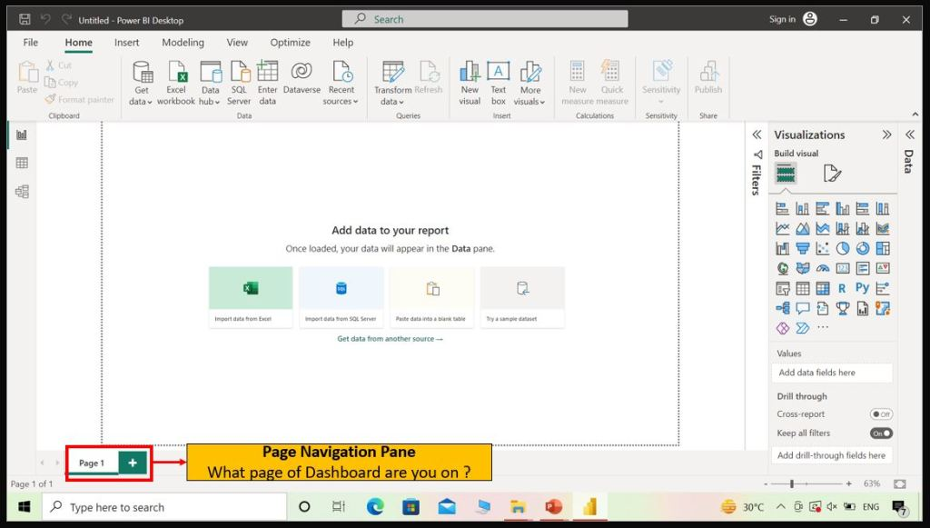
7. Expand and Collapse Pane:
You can expand and collapse the Filters, Visualizations, and Fields panes by selecting the arrows at the tops of the panes. Collapsing the panes provides more space on the canvas to build cool visualizations.

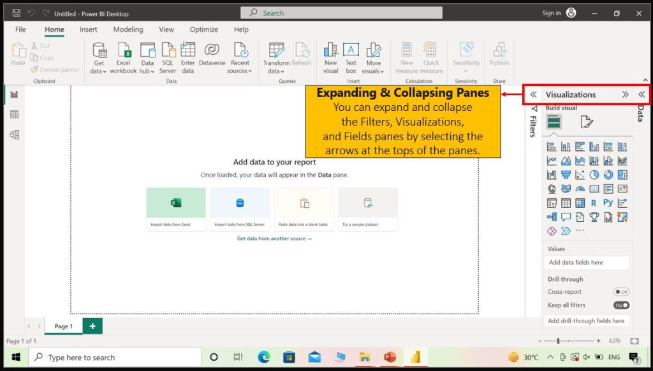

Step 4: Building a Simple Report
- Importing Data:
  - Open Power BI Desktop and click on Home > Get Data.
  - Select the data source (e.g., Excel) and load the data into Power BI.
  - Once the data is loaded, the fields will appear in the Fields Pane.
- Creating Visualizations:
  - Drag a field from the Fields Pane onto the Report View. For example, drag the Sales field onto the canvas to create a bar chart.
  - From the Visualizations Pane, select different chart types (e.g., bar chart, pie chart) to visualize the data.
- Customizing Visuals:
  - Use the options in the Visualizations Pane to customize the chart. You can modify titles, colors, and axes.
  - Add more visualizations by dragging additional fields into the Report View.
- Saving and Publishing:
  - Once the report is complete, click File > Save to save the report locally.
  - To share the report, click Home > Publish to upload it to the Power BI Service.

Conclusion:
In this experiment, we learned about the key components of Power BI and explored the Power BI Desktop interface. We walked through the process of creating a simple report by importing data, building visualizations, and customizing charts. By mastering these basic steps, users can leverage Power BI to analyze data and create insightful reports efficiently.

